[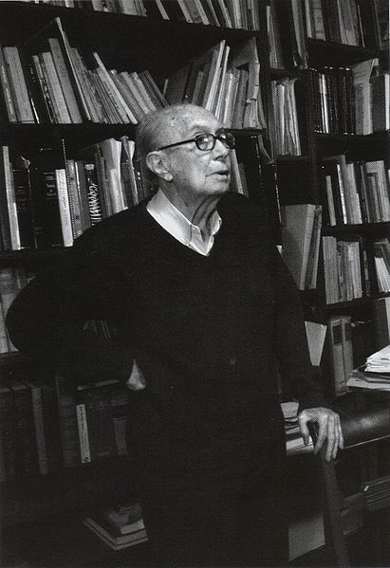](http://upload.wikimedia.org/wikipedia/commons/thumb/4/4c/Iturriaga01.JPG/411px-Iturriaga01.JPG)**Iturriaga (Romero), Enrique (1918–)**

Rafael Leonardo Junchaya

Enrique Iturriaga is a Peruvian composer and music pedagogue. He is one of the leader representatives of the so-called GENERACIÓN DEL 50, a Peruvian composers’ group that introduced the Modernist ideas to the musical life of Peru during the mid-20th century. Although Iturriaga’s production is not vast, it has been awarded several composition prizes and has been performed and published extensively. As a music teacher, he was a leading personality at the National Conservatoire of Peru, where he taught for over fifty years and was appointed twice as General Director. Iturriaga has experimented with diverse techniques depending on the demands of each individual work, which are always quite solidly constructed. His music shows the influence of Stravinsky and Bartók, and his style is close to that of other Latin American composers of the first half of the 20th century, such as ALBERTO GINASTERA or JUAN ORREGO SALAS. Iturriaga is deeply concerned with his Peruvian musical heritage, aiming to reconstruct it through a modern musical language.

Enrique Iturriaga was born in Lima but spent his childhood in the Northern countryside town of Huacho, where he met the popular music of the Peruvian coastal cultures. Back in Lima, Iturriaga studied piano with Lily Rosay and music theory with ANDRÉS SAS. Although he became a university student, he dropped out to attend the National Conservatoire, where he studied composition with RODOLFO HOLZMANN. Still a student, he was awarded the “Dunker Lavalle” National Prize of composition for his work *Canción y muerte de Rolando* (Roland’s song and death) in 1947.Iturriaga graduated as Music teacher in 1950 and travelled then to Paris, where he attended SIMONE PLÉ-CAUSSADE’s counterpoint class and also took lessons with ARTHUR HONEGGER. Back from Europe, Iturriaga gave private lessons and worked as music critic in “El Comercio”. In 1957 he was awarded the “Juan Landaeta” prize in Caracas for his work *Suite*. That same year, Iturriaga was appointed teacher at the National Conservatoire, a position that he kept until 2010 even years after his official retirement. During this period, Iturriaga was appointed general director twice: first in 1973–76 and then again in 1999–2002. A vast number of Peruvian musicians have attended his classes of harmony, counterpoint, analysis, history and composition.

Iturriaga composed *Vivencias* (Experiences) in 1965 as a commission for the 3rd Latin-American Festival. In 1971, he obtained the “Dunker Lavalle” prize a second time with *Homenaje a Stravinsky* (Hommage to Stravinsky), the first orchestral piece than featured the cajón as soloist. In 1974 the Peruvian National Army awarded Iturriaga another composition prize for *Sinfonía Junín y Ayacucho* after a contest proposed to commemorate the 150 years of the independency battles of Junín and Ayacucho. Other main works are: *Las cumbres* (Mountain tops), *Pregón y danza* (Street cry and dance), *Tres canciones para coro y orquesta* (Three songs for choir and orchestra) and *Cuatro canciones de Javier Heraud* (Four songs by Javier Heraud).

In spite of his not very large compositions’ catalogue, Iturriaga shows a diversity of musical languages in his works, ranging from tonality (*Sinfonía Junín y Ayacucho*) to twelve-tone serialism (*Vivencias*). Most of his works present diatonic-triadic materials, which are also elaborations of traditional Peruvian and Latin-American melodies and dance rhythms. Nevertheless, Iturriaga possesses a unique compositional style which is found not the language of his works but in his compositional method. He is clearly an organic composer, deriving every detail and the whole form and structure of his pieces from a unique cell or ‘seed’—as he refers to it. This feature has deeply influenced the work and ideas of his composition students, among them: Seiji Asato, Rafael Junchaya Gómez, Aurelio Tello, Rafael L. Junchaya and Benjamín Bonilla.

**List of works (selection)**

Writings

*Iurriaga, E. (1985) *Método de composición melódica*, Lima: Universidad Nacional Mayor de San Marcos.

*Iturriaga, E. and Estenssoro, J. C. (2007) ‘Emancipación y República: siglo XIX’, *La música en el Perú*, 2nd edition, Lima: Fondo Editorial Filarmonía: 103–124.

Compositions (selection)

*LA MÁQUINA for piano (1940)

*THREE PIECES FOR PIANO (1945)

*CANCIÓN Y MUERTE DE ROLANDO for soprano and orchestra, text by J. E. Eielson (1947)

*LAS CUMBRES for choir, text by S. Salazar Bondy (1950)

*PREGÓN Y DANZA for piano (1953)

*TRES CANCIONES PARA CORO Y ORQUESTA (1956)

*SUITE for orchestra (1957)

*VIVENCIAS for orchestra (1965)

*HOMENAJE A STRAVINSKY for solo cajón and orchestra (1971)

*SYMPHONY “JUNÍN Y AYACUCHO” (1974)

*CUATRO CANCIONES DE JAVIER HERAUD for voice and piano (1977)

*STRING QUARTET “MANORMEYOR” (2008)

**References and further reading**

Maloff, N. (2008) *Convergence of European, indigenous and popular idioms in the works of Peruvian composer Enrique Iturriaga*, doctoral thesis University of British Columbia, https://circle.ubc.ca/handle/2429/363.

Petrozzi, C. (2009) *La música orquestal peruana de 1945 a 2005: Identidades en la diversidad*, doctoral thesis, Helsinki: University of Helsinki Press.

Pinilla, E. (2007) ‘La música en el siglo XX’, *La música en el Perú*, 2nd edition, Lima: Fondo Editorial Filarmonía: 125–213.

Quesada Macchiavello, J. (1999) ‘Enrique Iturriaga’, *Compositores Peruanos del siglo XX* series (2), Lima: Pontificia Universidad Católica del Perú.